C++ Programming
Sheet 5 – Array (part1)
Q1. Determine whether the following array declarations are valid. If a declaration is invalid, explain why.
a. string employees[82];  b. int myArray[50;  c. int SIZE;  double list[SIZE];  d. int X = 50;  double list[X - 60];  e. int ids[-30];  f. names string[10]; | Answers:  - Valid  - The array size should be within []. The declaration should be: int myArray[50];  - The value of SIZE should be specified. The first line could be: int SIZE = 10;  - Because X = 50, X – 60 = 50 – 60 = -10. The array size cannot be negative. So the declaration could be: double list[X + 60];  - The array size cannot be negative. So the declaration should be: int ids[30];  - Invalid: The declaration should be: string names[10];

Q2. Write C++ statements to do the following:

- Declare an array beta of 20 components of type double.  - Initialize each component of the array beta to 0.  - Output the value of the fifth component of the array beta.  - Set the value of the ninth component of the array beta to 70.50.  - Set the value of the twelfth component of beta to four times the value of the eighth component of beta minus 15.  - Use a for loop to output the value of a component of beta if its index is a multiple of 3.  - Output the value of the last component of beta.  - Output the value of beta so that ten components per line are printed. | a. double beta[20];  b. for (int i = 0; i < 20; i++)  beta[i] = 0.0;  c. cout << beta[4] << endl;  d. beta[8] = 70.50;  e. beta[11] = 4 * alpha[7] - 15;  f. for (int i = 0; i < 20; i++)  if ( i % 3 == 0)  cout << beta[i] << " ";  cout << endl;  g. cout << beta[19] << endl;  h.  for (int j = 0; j < 20; j++)  {  cout << beta[j] << " ";  if ((j + 1) % 10 == 0)  cout << endl;  }  cout << endl;
Q3. What is stored in list after the following C++ code executes?
a.  int list[10];  for (int i = 0; i < 5; i++)  {  list[i] = i * i - 5;  if (i % 3 == 0)  list[i] = list[i] + i;  else  list[i] = list[i] - i;  } | -5 -5 -3 7 7
b.  int list[10];  list[0] = 2;  list[1] = 3;  for (int i = 2; i < 10; i++)  {  list[i] = list[i - 1] + list[i - 2];  if (i > 7)  list[i] = 2 * list[i] - list[i - 2];  } | 2 3 5 8 13 21 34 55 144 343
c.  double List[5];  List[0] = 3.0;  List[1] = 4.0;  for (int i = 2; i < 5; i++)  {  List[i] = List[i - 1] * List[i - 2];  if (i > 3)  List[i] = List[i] / 4;  } | 3.00 4.00 12.00 48.00 144.00

Q3. What is the output of the following C++ code?

#include <iostream>  using namespace std;  int main()  {  int beta[7] = {3, 5};  for (int i = 2; i < 7; i++)  {  beta[i] = 3 * i + 2;  beta[i - 1] = beta[i - 1] + beta[i];  beta[i - 2] = beta[i - 2] + beta [i - 1];  }  for (int i = 0; i < 7; i++)  cout << beta[i] << " ";  cout << endl;  return 0;  } | 16 32 44 56 68 37 20
#include <iostream>  using namespace std;  int main()  {  int list1[5];  int list2[15];  for (int i = 0; i < 5; i++)  list1[i] = i * i - 2;  cout << "list1: ";  for (int i = 0; i < 5; i++)  cout << list1[i] << " ";  cout << endl;  for (int i = 0; i < 5; i++)  {  list2[i] = list1[i] * i;  list2[i + 5] = list1[4 - i] + i;  list2[i + 10] = list2[9 - i] + list2[i];  }  cout << "list2: ";  for (int i = 0; i < 7; i++)  cout << list2[i] << " ";  cout << endl;  return 0;  } | list1: -2 -1 2 7 14  list2: 0 -1 4 21 56 14 8

Q4. Write a C++ program that declares an array alpha of 50 components of type double. Initialize the array so that the first 25 components are equal to the square of the index variable, and the last 25 components are equal to three times the index variable. Output the array so that 10 elements per line are printed.
#include <iostream>
#include <iomanip>

using namespace std;

void initialize(double list[], int size);
void print(double list[], int size);

int main()
{
double alpha[50];

initialize(alpha, 50);
print(alpha, 50);
return 0;
}

void initialize(double list[], int size)
{
int count;

for (count = 0; count < 25; count++)
list[count] = count * count;

for (count = 25; count < size; count++)
list[count] = 3 * count;
}

void print(double list[], int size)
{
int count;

for (count = 0; count < size; count++)
{
cout << list[count] << " ";
if ((count + 1) % 10 == 0)
cout << endl;
}
cout << endl;
}

Q5. Determine whether the following array declarations are valid. If a declaration is valid, determine the size of the array.
a. int list[] = {18, 13, 14, 16};  b. int x[10] = {1, 7, 5, 3, 2, 8};  c. double y[4] = {2.0, 5.0, 8.0, 11.0, 14.0};  d. double lengths[] = {8.2, 3.9, 6.4, 5.7, 7.3};  e. int list[7] = {12, 13, , 14, 16, , 8};  f. string names[8] = {"John","Lisa", "Chris", "Katie"}; | a. Valid. The size of list is 4.  b. Valid. The size of x is 10.  c. Invalid. The size of y is 4. However, the number of array initializers is 5, exceeding the size of the array.  d. Valid.  e. Invalid. When initializing an array during declaration, all elements that follow the first unspecified element must be unspecified.  f. Valid.

Q6. Suppose that you have the following function definition:
void sum(int x, int y, int& z)
{
z = x + y;
}
Consider the following declarations:
int list1[10], list2[10], list3[10];
int a, b, c;
Which of the following function calls is valid?

a. sum(a, b, c);  b. sum(list1[0], list2[0], a);  c. sum(list1, list2, c);  d. for (int i = 1; i <= 10; i++)  sum(list1[i], list2[i], list3[i]); | a. Valid.  b. Valid.  c. Invalid.  d. Valid.

Q7. What is the output of the following program?
#include <iostream>  using namespace std;  int main()  {  int j;  int one[5];  int two[10];  for (j = 0; j < 5; j++)  one[j] = 5 * j + 3;  cout << "One contains: ";  for (j = 0; j < 5; j++)  cout << one[j] << " ";  cout << endl;  for (j = 0; j < 5; j++)  {  two[j] = 2 * one[j] - 1;  two[j + 5] = one[4 - j] + two[j];  }  cout << "Two contains: ";  for (j = 0; j < 10; j++)  cout << two[j] << " ";  cout << endl;  return 0;  } | One contains: 3 8 13 18 23  Two contains: 5 15 25 35 45 28 33 38 43 48

Q8.
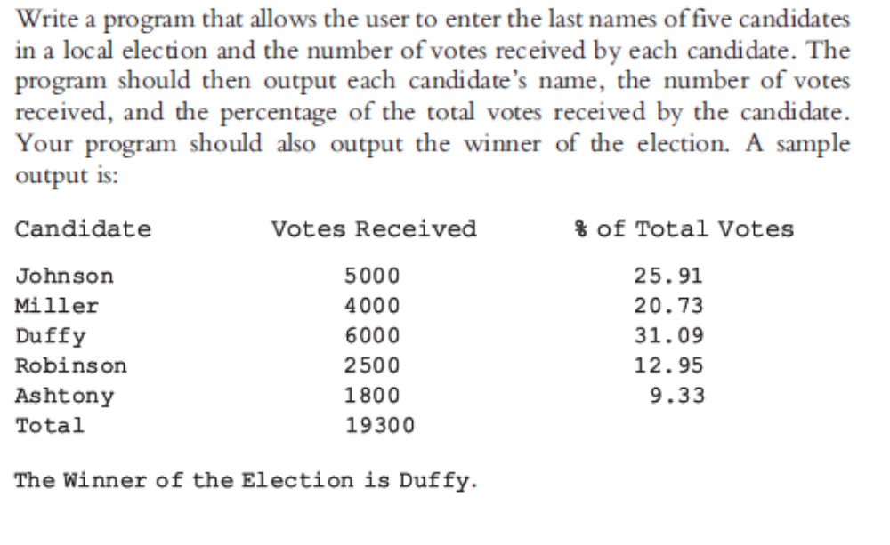
Answer:
#include <iostream>
#include <iomanip>
#include <string>

using namespace std;

int sumVotes(int list[], int size);
int winnerIndex(int list[], int size);

int main()
{
string candidates[5];
int votes[5] = {0};
int totalVotes;
int i;

cout << "Enter candidate's name and the votes received by the candidate." << endl;

for (i = 0; i < 5; i++)
cin >> candidates[i] >> votes[i];

totalVotes = sumVotes(votes, 5);

cout << "Candidate Votes Received % of Total Votes" << endl;
for (i = 0; i < 5; i++)
cout << candidates[i]<<" " << votes[i] << " "
<< (static_cast<double>(votes[i]) / static_cast<double>(totalVotes)) * 100 << endl;

cout << "Total " << totalVotes << endl;

cout << "The Winner of the Election is "
<< candidates[winnerIndex(votes, 5)]
<< "." << endl;

return 0;
}

int sumVotes(int list[], int size)
{
int sum = 0;

for (int i = 0; i < size; i++)
sum = sum + list[i];

return sum;
}

int winnerIndex(int list[], int size)
{
int winInd = 0;

for (int i = 0; i < size; i++)
if (list[i] > list[winInd])
winInd = i;

return winInd;
}

